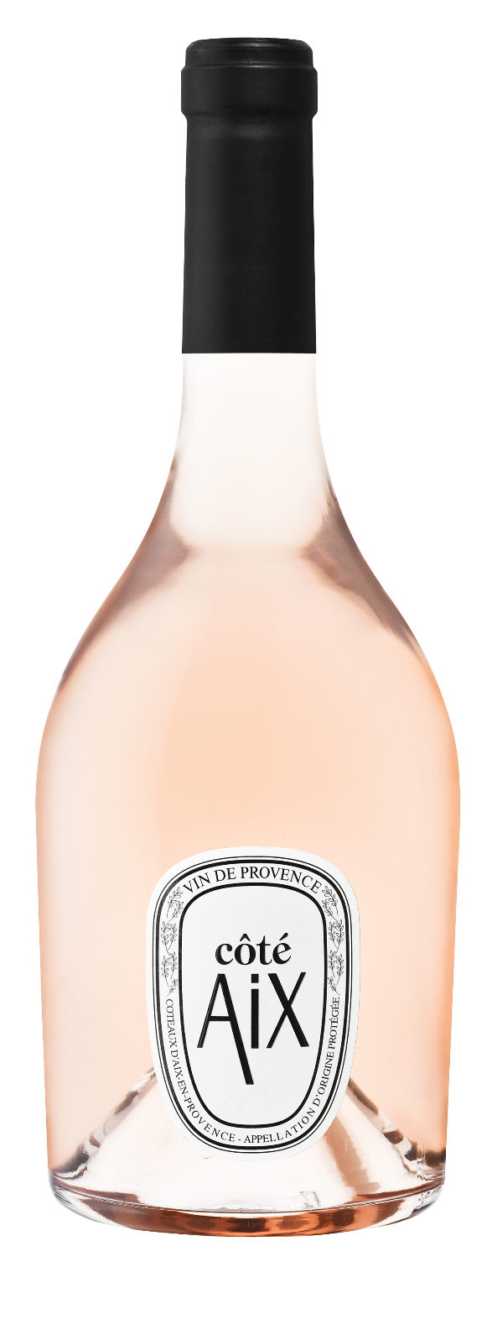
Côté AIX

AOP COTEAUX D'AIX EN PROVENCE

Rosé - ORGANIC WINE
75 cl – EAN: 3455098400312
12, 5 %. Vol

Coté AIX embodies the best of the Mediterranean, an enchanting setting illuminated by the sun of Provence. From an exceptional terroir of vines, olive trees and oak trees, this vibrant wine will seduce you with its explosion of freshness.

TERROIR
Facing south, the soil is sandy and permeable. It is mainly composed of schist, micaschist and white quartz.

grape varieties
Grenache, Syrah


FOOD AND WINE PAIRING
Eggplant caviar, prawn risotto, apple pie

